**JOHANA GIKONYO KIHIU**

johanagikonyo552@gmail.com

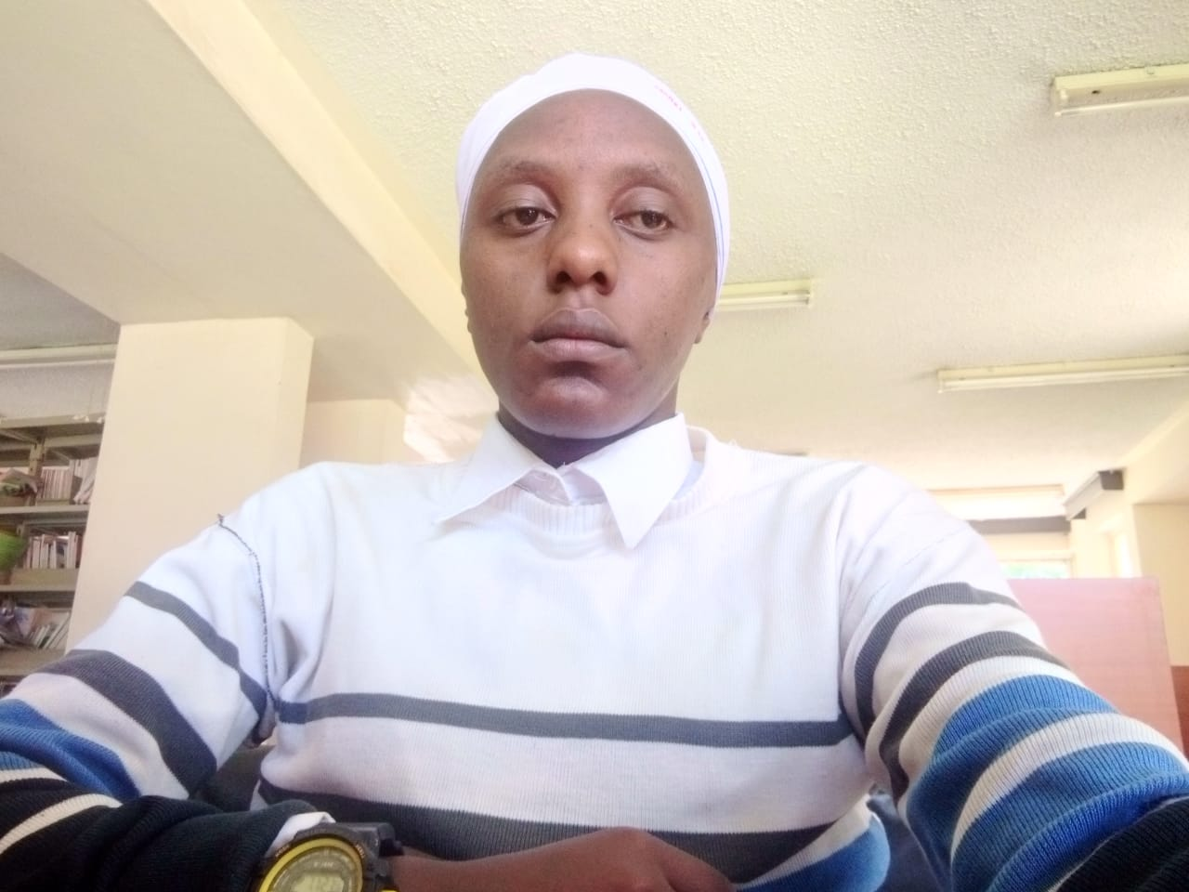**Personal Profile Statement**

**A motivated, adaptable and responsible Software**

**Developer (Web Developer) . I am currently seeking**

**an IT position which will utilize technical skills developed**

**through past experience in this field.**

**I have a methodical, customer-focused approach to work and a**

+254742377527/+254740550484

github.com/JohanaGikonyo

LinkedIn : Johana Gikonyo

**strong drive to see things through to completion.**

**In my career journey, I have managed to create different business**

**marketing softwares for different organizations.**

**Relevant Experience**

**Software Engineer Freelance Sep 2022 - Present**

**● Client collaboration. Collaborate with clients to understand**

**their requirements.**

**● Documentation. Document requirements to define project scope.**

**● Custom software solutions. Designed and developed tailor-made**

**software solutions**

**● Continuous learning. Stayed current with emerging technologies**

**and trends in the software world.**

**● Portfolio growth**

**Selected GitHub Projects**

**Shopify – link https://github.com/JohanaGikonyo/Food-order**

**E-comerce site perfoming all the functionalities of an e-commerce**

**platform including user registration order processing and payment**

**Stacks – postgreSQL server, React, JavaScript, tailwindCSS.**

**I also got to work with maps to pick out locations.**

**Stacks – MongoDB, React js, TailwindCSS, Nodejs, JavaScript, Express .**

**I got a chance to Implement administration rights allowing one to edit the blog articles.**

**Stacks – React js, TailwindCSS , Mongodb .**

**Skills**

**Programming Languages**

JavaScript, Typescript, HTML, CSS, Node JS, Python.

**Libraries & Frameworks**

React, Next js, TailwindCSS, Express js, Prisma

**Tools & Platforms**

Git, Github, Vercel, Render, postgresql,

SQL server, MongoDB, Postgresql

**Education**

**Multimedia University** Bachelor of

Science in Mathematics and Computer Science.

**Interests**

lifting, nature documentaries.